AP Calc WS#2 Prerequisites 2 for Calculus Name: _________________

1. Convert to the other mode then show graph on both modes for stamp (made use of on/off equation)

Parametric mode Function mode

|  |  |
| --- | --- |
| x = 3t; y = 9t2 - ∞ < t < ∞ |  |
| x = cos(t); y = sin(t) |  |
|  | y = 2x + 3 |
|  | x = y2 |
| x = 4cos(t); y = 2sin(t) $0≤t≤2π$ |  |
|  | $y=\sqrt{9-{(x-2)}^{2}}+4$ |

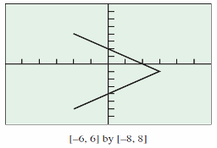2. Write the equations in both parametric and function to produce this graph on calculator

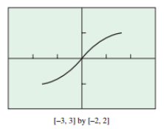

3. Given a function, find its inverse. Convert them to parametric and graph both of them in both mode (parametric and function).

a. y = 2x + 3 b. y = (x – 1)2

c. d. y = x2 + 2x + 4

4. Solve for x

(1.045)x = 2 e0.05x = 3 ex + e-x = 3 2x + 2-x = 5

5. Let find the horizontal and vertical asymptote

Now find its inverse function and the inverse's the horizontal and vertical asymptote

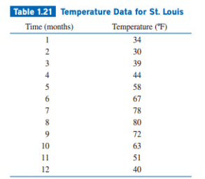6. Table 1.21 gives the average monthly temperatures for St. Louis for a 12-month period starting with January. Model the monthly temperature with an equation in both cosine and sine form, also use regression feature on calculator

7. Use the given information to find the values of the angle in degree and radian, then find the six trigonometric functions at the angle . Give exact answers.

a. $θ=\sin^{-1}\left(\frac{8}{17}\right)$ b. Point P(-3, 4) is on terminal side of

8. Sarah invests $1000 in an account that earns 5.25% interest compounded ____?ly. How long will it take the account to reach $2500? With that same time, what rate will take the account up to $5000?